THE CHURCH OF CENTRAL AFRICA PRESBYTERIAN
BLANTYRE SYNOD
YOUTH AND SUNDAY SCHOOL DEPARTMENT
Dynamic Youth Equipped and Focused in Christ

I am Rev. Dennis Mulele, the CCAP Blantyre Synod Sunday school and Acting Youth Director. I welcome you all to visit this department whenever you are around the Synod offices which are allocated along the Chileka road near Henry Henderson Institute Secondary school in Blantyre.
1. Background
The Blantyre Synod Youth Department was established in the 1950’s in order to facilitate and implement youth activities within its jurisdiction. However, the Sunday school division started on the inception of the Church of Scotland in 1876. The boys and girls brigade followed in 1910. Its purpose was to facilitate Bible studies among the youth. Through youth camps at the lake, parading and sporting activities, many youths were attracted but it was banned in Malawi on political grounds. CCAPSO which started initially in 1998 at the University of Malawi, the Polytechnic, was officially launched in 2000. The Minister’s Children Association was launched on 28th December, 2008. In June, 2010, the Blantyre Synod established the Sunday school department in order to elevate the status and importance of children in the church.
2. Goals and Objectives
The Synod Youth department outlines the following to guide and, measure its success:
- Vision: Dynamic Youth equipped and focused in Christ

- Mission Statement: In line with the mission of the Church of Central Africa Presbyterian, Blantyre Synod, and the Synod Youth Department is committed to a well structured and coordinated management and leadership. This will be achieved through empowerment, promotion, mobilization and networking.

- Goals: To convert and disciple youths for Christ
: To collect as much data as possible for informed decision making.

- Objectives: Increase discipleship among youths by 2012
: Increase youth’s participation in the church ministry and community
Activities by 2012
: Enhance youth’s economical independence and corporate basis by
2012
3. CCAP Structure
 |  | General Assembly
 |  | Standing Committee
 |  | Secretary General
DGS (Development) | Treasurer General |  |  |  |  |  |  |  | DGS (Ministry Work)
 |  |  |  |  |  |  |  |  |  | Youth Desk
 |  |  |  |  | Link to Youth Department of Synods

4. Functions of Youth Desk and Process
- Harmonize the practice and recognition of Youth
- Organize general assembly youth conferences before general assembly (Pre-conference)
- Coordinate youth work in CCAP
- Be CCAP’s voice on youth affairs
5. Functions of Synod Youth Committee
- To coordinate the work and Christian life of the youth of the Synod and prepare programmes for the youth work
- To recommend policy direction regarding youth work within the synod
- To coordinate and provide for the training of the youth, including the training of Sunday school, catechumen and others.
- To encourage the study of and response to the needs of young people and facilitate local congregation in the work of evangelism, training, retreat and nurture of young people
- Coordinate and supervise the work of the church’s student organization in schools
- To receive reports from Presbytery youth committees on the state of youth work in the church and to visit the presbyteries to inspect and encourage youth work therein.
- To recommend and nominate youth delegates to Synod meetings and general assembly meetings.
- To organize Synod Youth conferences at least once every two years and make resolutions for the Synod to forward to the General Assembly for consideration.
- To supervise the work of the Synod youth centers
- To formulate and recognize policy guidelines on the work and role and integration of the youth in the church.
- To unite the youth of the church in the dedication of their love to Jesus Christ and his service in the home, the community and the church.
- To provide or arrange for the training and grounding of the youth in Presbyterian faith and system of worship
- To provide a link with the youth of other synods of the general assembly and arrange and coordinate exchange visits and joint prayer sessions
- In liaison with women’s work committee to coordinate young boys and girls counseling
- To coordinate AIDS activities and programs among the youths in the church.
- To ensure youth literature is available
6. Functions of Presbytery Youth Committee
- Generally to oversee and encourage work amongst young people in the Presbytery and in the congregation
- To receive reports from the Presbytery youth coordinator and to give him guidelines and encouragement in his work
- The Youth department receives financial resources from internal and external sources. Internally it receives funding from the main Blantyre Synod funds. Externally it is currently supported through donor funding specific projects and programs by Scottish world exchange and Pittsburgh Presbytery.
- It is important for youth department to maintain links with the Church of Scotland, Scottish world exchange and Pittsburgh presbytery.
- Within the country the youth department has linkages with the Nkhoma and the Livingstonia synods. It is also linked t other Para-Church organizations, faith based and religious institutions, such as Interfaith Aids association in Malawi, Ecumenical Counseling Centre, Youth Commission of the Evangelical Association in Malawi, Malawi Economic Justice Network, Commonwealth Education Fund, Anti-Corruption Bureau.
7. Recent Achievements
- Have facilitated the implementation of environmental period, youth tree planting project which is an annual event between January and March. The youths from approximately 510 congregations and 600 prayer houses of Blantyre Synod participated in this exercise.
- Have facilitated the Synod youth week in April this year. During this period the youth discussed issues of corruption. The discussed the issue of Judas who took a bribe from the priests and the chief priest who bribed the Roman guards to say that Jesus was stolen. The youth also discussed their strength, weakness, opportunities and threats they have in fighting against corruption in the church.
- Have facilitated two youth conferences and AGMS at synod level in 2007 and 2009 in which youths from different presbyteries attended.

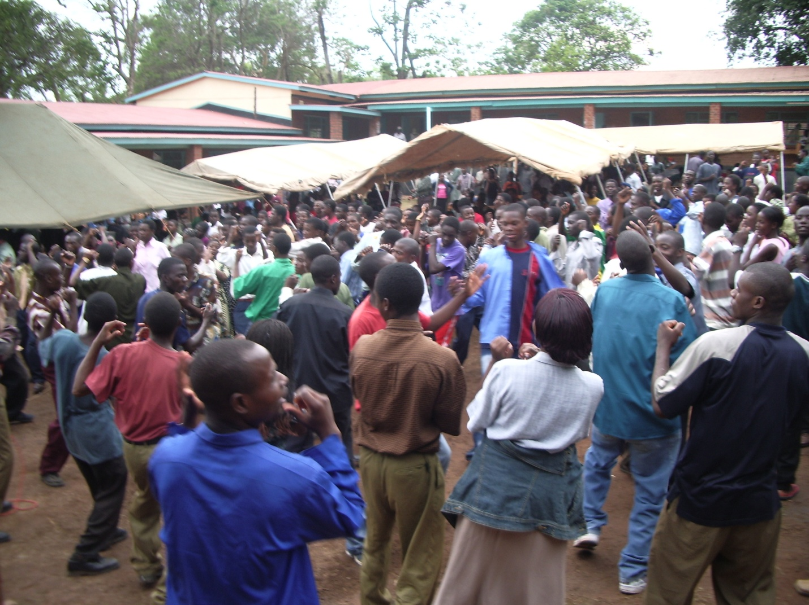

Above the youth are singing a chorus.

- Have established links with the Anti-Corruption Bureau and Athletes in Action. The leaders within Blantyre City Presbytery were trained in a Biblical approach to Sports ministry by the Athletes in Action. This will go up to other presbyteries.
- Have facilitated Sunday school book review project phase 1. Sunday school experts Revs. Hudson Kaseko, William Mawindo, Master Jumbe and Dennis Mulele are the ones who are reviewing the Sunday school books. This project has been initiated due to scarcity of Sunday school books for almost 10 years and were not marching the modern teaching skills. It now requires enough funding for production of the books.
- Have facilitated Sunday school teacher’s trainings in children ministry in foundation. Almost 250 teachers have been taught in story telling techniques, crafts, memory verses, games and play, teaching techniques.
- Have established Inter-Presbytery children talent promotion period in which children showcase their talents.
8. Projects and Activities for 2011
- To facilitate establishment of football and netball teams in all Blantyre Synod congregations as part of sports evangelism among the youth.
- To facilitate the establishment and implementation of Sunday school children’s week and children’s Sunday

- To facilitate workshops on child trafficking and children’s rights;
globe warming and climate change
9. Potential Future Project
- To establish Sunday school teacher’s training, resource, recreation centre.
- Development of youth bible study guides
10. Recommendation
For all these projects to take place very effectively there is need for the department to acquire a vehicle for easy monitoring and mobility. There is also need to have an internet facility at the department.
11. Leadership at the Youth and Sunday school Department
- The Youth and Sunday school department is currently being headed by Reverend Dennis Mulele
- CCAPSO is being taken care of by Mr. Joy Khangamwa
- Schools chaplain is being headed by Reverend Cliff Nyekanyeka
- There is need to have a Boys and Girls brigade officer

May the Good Lord bless you as you pray and think of importance of the status of the youth and children of CCAP Blantyre Synod.

Rev. Dennis Mulele
BTh (Hons), (MTh Student. UFH)

